Goodyear Ski Club presents —
Copper Mountain ~ Member price $959*
Sunday, February 25 – Friday, March 2, 2018
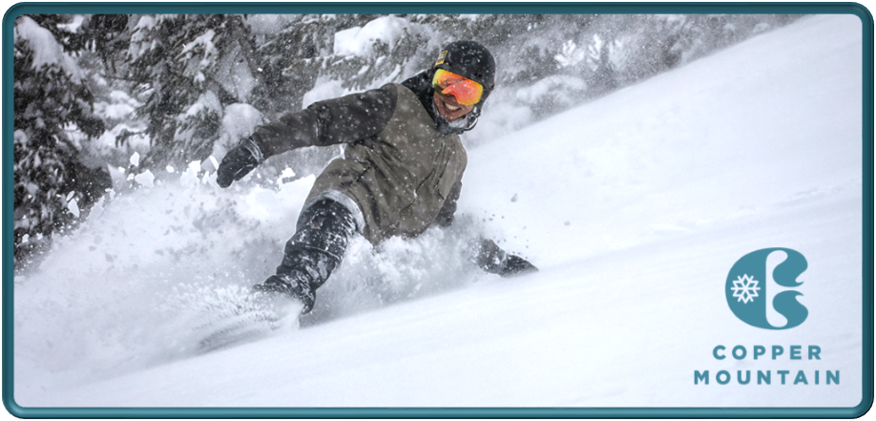
Goodyear Ski Club, Inc (GSC) Trip Agreement (Revised July 26, 2013)
Deposit of $359 is due with signed trip agreement
Nonmembers must include completed membership application and dues payment *
Second payment of $300 is due by November 1, 2017
Final payment of $300 is due by January 1, 2018
Trip insurance is recommended (optional)
Make checks payable to Goodyear Ski Club
Send check and signed trip agreement to:
Teresa Gifford
2875 Norma Street
Cuyahoga Falls, OH 44223
Phone: 330-714-3643
Email: roscomoy@aol.com
Includes:
- 5 nights at Passage Point 2-bedroom condominiums, 4 persons per condo. Passage Point is in the Center Village of Copper Mountain Resort, approximately 150 yards from the American Eagle lift. It is a newer property, close to everything, yet away from the crowds. Ski lockers are off the lobby.
- 4-day lift tickets at Copper Mountain. Copper has 2465 skiable acres, a base elevation of 9700 feet and peak elevation of 12,313 feet. Great views and light powder snow are features of Copper.
- Welcome reception and mid-week party.
- Southwest Airlines roundtrip flights from Cleveland to Denver. Free baggage!
- Ground transfers from Denver Airport to Copper via Arrow Stage Lines. Copper is located just 100 miles from Denver Airport or 1 hour and 35 minutes travel time. Driver tips are included.
* Please note: Trip is open to Goodyear Ski Club members ONLY until August 7, 2017. Nonmembers may apply after that date. The nonmember price includes a one-year membership to Goodyear Ski Club. A completed membership application and dues payment must accompany your trip agreement and deposit. This requirement may be waived for members of Cleveland Metro Ski Council ski clubs.

Unless otherwise noted, all prices are “per person, double occupancy”. All trip reservations require a signed application with payment.
Make all checks payable to the Goodyear Ski Club, Inc. No post-dated check(s) will be accepted for any GSC trip. Unforeseen costs from changes to air travel, ground travel, lift tickets or rooming will be passed on to the trip participants.
CANCELLATION AND/OR CHANGES: GSC reserves the right to: (1) withdraw the trip; (2) refuse, at any time, to accept or retain any person as a trip participant; and/or (3) prior to departure, make changes in published itinerary, whenever, in its sole judgment, conditions warrant.
FUEL SURCHARGES: The GSC may incur additional fuel surcharges to the contracted transportation at any time before trip departure. It is the responsibility of the participant to pay any such increases. Participants having any questions regarding this policy should contact their trip leader.
ROOMING PREFERENCES: Due to the nature of our trips, the number of participants, the bedding configuration, and the accommodations secured for the trip participants, the GSC cannot guarantee that the requested rooming preference will be provided.
SINGLE SUPPLEMENT: Room rates are based upon double occupancy. If you are a single participant, without a roommate preference, every effort will be made to find you a roommate. If that is not possible, you will be required to pay any single supplement charges that may be imposed.
RESPONSIBILITY: GSC is acting as the applicant’s agent and will not be liable for any loss or damage to baggage or property, or any personal injury, or any other loss occurring or occasioned by applicant’s participation or lack of participation in a trip. GSC will not be responsible for any cost increase(s) due to increases in local, state, or Federal taxes, fuel surcharges, baggage fees, etc. Any participant under 18 years of age must be accompanied by a parent or guardian.
REFUNDS: Applicant will receive a full refund if the GSC cancels a trip, except and unless such cancellation is necessitated or caused, either wholly or in part, by applicant’s cancellation or failure to make timely payment. 1) Where applicant cancels at any time and trip departs 100% filled, the applicant may be entitled to a refund, less a $5 service charge on any one day trip; a $15 service charge on any weekend trip; or a $25 service charge on any trip over three days. 2) Where applicant cancels and a trip departs less than 100% filled, the applicant may be liable for the entire cost of the applicant’s trip, including deposit, final payment and/or balance due. 3) Applicant shall be liable to the GSC for any monies expended or paid by GSC over and above payments made by the applicant to the GSC.
NSF CHECK: For any check returned for insufficient funds, the participant will be assessed a $25 minimum return check fee, plus any daily penalties incurred by the GSC. The return of any check will be cause for cash payments to be made to the GSC Treasurer. If checks are returned for insufficient funds, the Treasurer shall notify the participant and allow him/her fourteen (14) days to cover the check. If funds have not been paid within the fourteen day period, the member may lose his/her position on any GSC trip or activity.
TRIPS OUT OF THE COUNTRY: You must have a current passport, which does not expire until 6 months after your return. If you have been convicted of a crime, including D.U.I., you may be refused entry into the subject country and should contact the country’s embassy or Consular General for the proper procedure or clearance. The GSC is not responsible for the denied entry.
ASSOCIATE MEMBER: To protect the GSC’s non-profit status, each non-member is charged an Associate Membership fee based upon a non- refundable fee structure of: $5 for each one day trip; $10 for each weekend trip; and $25 for any trip longer than three days. This fee allows an individual to participate on a current season ski trip. Within one month from the ending date of the respective trip, the Associate Membership fee may be applied toward a full membership. The fee does not entitle the Associate Member to receive the monthly newsletter or any other GSC benefits. The Associate Membership fee will be in effect only after a trip is opened to non-members.
NOT INCLUDED: Any items not specifically mentioned as part of the trip, such as: meals, phone calls, transportation to the point of trip departure, items of a personal nature, fees charged for airlines for checked baggage, etc. are the sole responsibility of the trip participant.
RELEASE: In consideration of being permitted to participate in trip activities, by signing the application, I, as an individual hereby release the GSC, its officers and agents, from all liability for injury, death, damage or loss resulting from such participation. I understand the dangers inherent in trip activities and acknowledge that I have had an opportunity to make all necessary inquiries regarding the transportation and facilities involved. I release the GSC to use my likeness which may appear on their website to publicize their ski trips, which may appear in their photo albums or which may appear in other media used to publicize the GSC and its activities. I am gifting a portion of my trip fee (eligible reimbursement/# of trip participants) to the Trip Coordinator. I intend this release to be binding on my heirs and personal representatives. If I am the parent or legal guardian of a trip participant, I intend the above release to be applicable to the participant as well as to me.
Trip # ____ Destination ___________________________________________________________ Deposit $________ Full Payment $___________
Name _________________________________________________________________________ D.O.B.________________________ (MM/DD/YYYY)
(As shown on passport or driver’s license)
Name _________________________________________________________________________ D.O.B.________________________ (MM/DD/YYYY)
(As shown on passport or driver’s license)
Address _______________________________________________________________________ Phone _________________________________
City ______________________________ State ____ Zip __________ E-mail _______________________________________________________
Emergency Contact Name_________________________________________________________ Phone _________________________________
Rooming Preference _____________________________________________________________________________________________________
Signature _________________________________________________________________________________ Date ________________________
Signature _________________________________________________________________________________ Date ________________________
I, we, have read and agree to the terms and conditions set forth in the Trip Agreement, as they pertain to this trip
Goodyear Ski Club Membership Application
www.GoodyearSkiClub.org
New Member (Referred by)
Name(s)
Children’s First Names (if members)
Birthday(s) _
(in order of names above) MM/DD MM/DD MM/DD MM/DD MM/DD MM/DD
Mailing Address
City State Zip Code -
Home Phone Cell Phone Work Phone
Email Address(es)
Newsletter Distribution (check one) Email (free) US Mail ($6)
Category (check one) Female Male Couple Family
Fees  (Circle Amounts) | New Members &  Late Renewals | Renewals  Due Oct. 1 | Wear nametag at meetings for a chance to win cash.  ____________________________________________  Print exactly what you want your nametag to read.  ____ Optional Nametag (Cost: $5.00 each)  ____ Optional GSC Flag (Cost: $3.50 each)  ____ Optional GSC Pin (Cost: $4.00 each)  Include tag/flag/pin payment with application.  Make check payable to Goodyear Ski Club.  Send check and completed application to:  Goodyear Ski Club, Inc.  3465 S. Arlington Rd, Ste. E #178  Akron, OH 44312
Single | $25.00 | $18.00
Couple | $35.00 | $27.00
Dependent (each)  under 18 with parent  membership | $5.00 | $5.00
Newsletter via US Mail | $ 6.00 | $ 6.00
Total Enclosed: | ______________
NOTICE: By signing below and/or accepting any membership benefit, and/or by participating in any Club activity, applicant/renewer releases the Goodyear Ski Club, Inc. (the Club), its officers, board members, chairpersons, and members from any and all liability or claim, including theft, property loss, accidents, death of or injury to themselves, family members, or guests, arising from participation in any Club activity, whether resulting from negligence or otherwise. I am also gifting a portion of my dues (eligible reimbursements divided by number of members) to Club officers and supplemental positions.
Signature(s) Date
Signature(s) Date
If under 18, parent(s) or guardian(s) must sign
8/1/2016
E-mail version includes color.
Mailed version is black & white.
In addition to my name, GSC has my permission to include items listed in this box in the member directory.
(Cross off any items to exclude.) Mailing Address — Home/Work/Cell Phone — Email — Birthday

