

The Wilson Hotel
A Residence Inn by Marriott Big Sky
Includes: Lodging at the 4.6-star hotel, daily breakfast, and transportation.

Two queen bed hotel rooms-8 available
King bed hotel rooms-4 available
$2200 Land only
$2850 with AIR no Lift

Single options available add $1905.

Only 24 spots--$600 saves your space.

Multiple Pass options Available

IKON or Free Style PASS

5,850 acres of wide-open Montana terrain at Big Sky Resort.
Trip Leader: Denise Malovich
ddm183@hotmail.com
724/813-6209

Register online:
http://warren-bs.sat.tours/

Big sky, montana
march 14-21, 2027

5,850 acres of wide-open Montana terrain at Big Sky Resort!

THE WILSON HOTEL (406) 995-9000
After a day on the slopes, enjoy recreational amenities including an outdoor pool and a hot tub. Additional amenities at this hotel include complimentary wireless internet access, concierge services, and an arcade/game room.
- Daily Breakfast
- Daily $20 food and beverage credit
- Daily Mountain Amenity
  - Reusable water bottles
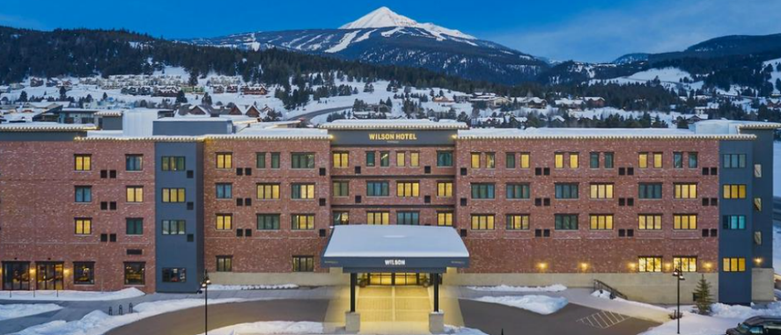
  - Goggle Cloth


You'll be on the slopes in no time with the complimentary ski shuttle.

