Lewis Ski Club presents
Breckenridge, Colorado
Sat., Feb. 20th – Sat., Feb. 27th, 2021
$1,700



Package includes
- 7 nights at Beaver Run Resort; spacious 2 bedroom / 2 bath condos includes porter fees, fireplace, balcony & fully equipped kitchen
- Ski in / Ski out just steps from the Beaver Run Superchair
- Ski lockers located near lift, Breck Sports on-site rentals and retail shop, on-site ski school, several restaurants, market & deli, hot tubs, spa & oxygen bar, sauna, steam room, fitness center, arcade, complimentary indoor mini-golf
- Roundtrip flight from Cleveland to Denver on Southwest
- Roundtrip ground transportation from Denver airport to Beaver Run Resort.
- Wine & cheese welcome reception, mid-week lunch & dinner

Epic 5-day Day Pass included
- A restricted Epic Day Pass is included when you make pmt. #3. This pass is not valid for use on certain holiday dates: Nov 27 & 28, Dec 26-31, Jan 16, Feb 13 & 14.
- Includes skiing at Breckenridge and Keystone.
- Ability to reserve ski days via Vail Resorts reservation system.
- The pass will be purchased and issued in your name.
- These passes are non refundable and non transferable.
- Epic Coverage is included with all pass purchases. Coverage includes: personal events such as job loss, Stay-At-Home order from county, state, country, injury, resort closures for reasons such as COVID-19 or related diseases and more. Members agree to be subject to the terms and conditions of Epic Coverage. Full details and terms and conditions can be found here. https://www.epicpass.com/info/epic-coverage.aspx
- Full details of Epic Day pass products including resort coverage and pass holder benefits available at www.epicpass.com
To purchase an Epic Pass on your own
- Pay only $1,244 for the package by omitting pmt. #3
- Make your purchase using the link on our homepage
- Contact the trip leader after you’ve purchased your pass
Breckenridge 2021 Payment Schedule
1st payment $500 due now, non-refundable
2nd payment $518 due Sept. 30, 2020
3rd payment $456 due Nov. 30, 2020
*Current Epic Pass holders omit 3rd payment
4th payment $226 due Dec. 28, 2020

Optional 6th day lift ticket
Adult $83 due Nov. 30, 2020
Senior $43 due Nov. 30, 2020
Current pricing is only guaranteed until Vail Resorts current pricing expires, after which pricing will almost certainly increase. Pricing increase deadline date is yet to be confirmed.
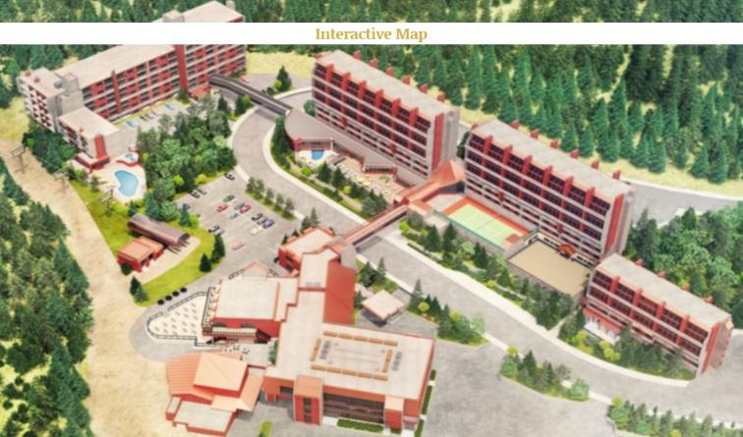

Beaver Run Resort is located on Peak 9 which shelters gentle wide open green slopes, some of the least crowded blue runs at Breck, as well as the steepest and most challenging terrain. Peak 9 is also home of the EpicMix Racecourse, Highway 9 Terrain Park and free mountain tours daily right from Beaver Run.

Mountain stats
Trails 187
Longest run 4 O’clock; 3.5 miles
Vertical drop 3,398 ft.
Groomed trails 1,400 acres
Base elevation 9,600 ft.
Summit elevation 12,998 ft.
Ski with a Ranger Free every Friday 11 am - noon

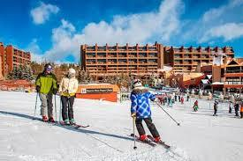

For more information:
Contact Shari: breckenridge2021@lewisskiclub.org

*Travel insurance is strongly recommended. Time limits may apply.
***Price does not include airline baggage fees, any additional fuel surcharges, or airport fees, which may be imposed by the airline prior to departure. Lewis Ski club reserves the option to change airlines, lodging and/or itineraries.

