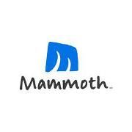
Fagowees 2020 Mammoth Mountain Ski Trip
Cancellation Policy 12/17/2019
When: Saturday, March 14th – Saturday, March 21st 2020
- 7 nights lodging at Mammoth Mountain Inn
- 2 Bedroom Condo’s with loft – 6 to 7 people in a unit
- 5 days lift ticket to Mammoth Resort
- Bus transport to/from Reno airport (flying into Reno)
- 2 parties and 1 dinner
Pricing :
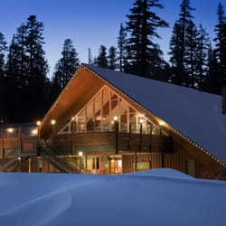
- Ground package: $1,200 (Member), $1240 (Non-member)
- W/Airline $1,855 (Member), $1895 (Non-member)
Airline Information:
DL / 358 14MAR2020 CLE 745A SLC 958A
DL / 978 14MAR2020 SLC1125A RNO 1155A
DL / 969 21MAR2020 RNO 116P ATL 830P
DL / 485 21MAR2020 ATL1012P CLE 1157P

Payment Schedule | Member Ground | Non-Member Ground | Member  w/air | Non-Member  w/air
Deposit | $300 | $300 | 300 | 300
9/17/2019 | $300 | $300 | 300 | 300
11/5/2019 | $300 | $300 | 600 | 640
1/7/2020 | $300 | $340 | 655 | 655

Contacts: Alicia Christy (440) 554-6055 alicia829@roadrunner.com
Tom Keller (216) 224-1066 tompkeller@gmail.com
** If you are interested in an ikon pass, talk to us prior to purchase (deadline for $30 discount is 4/22) **
** 1 Bedroom Condo units available, see trip leaders for Details & pricing **

