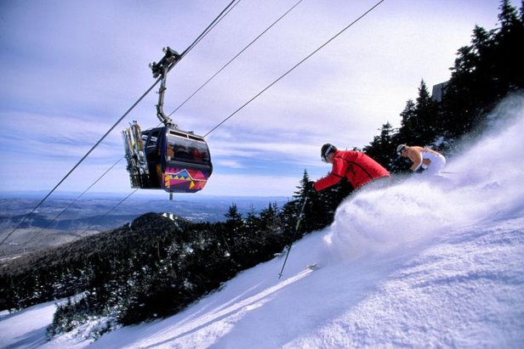


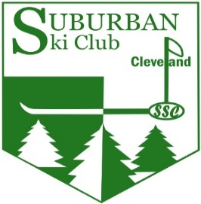

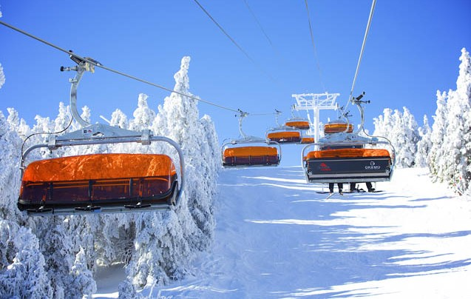

Come Join Suburban Ski Club as We Travel to
Killington and Okemo, Vermont
Sunday, February 12 – Saturday, February 18, 2023
This is an all-inclusive trip and your bargain price of $1550 includes:
    - Luxury motor coach transportation with breakfast, boxed lunch and snacks
    - Five-day lift ticket: four days at Killington & Pico and a day at Okemo
    - Lodging at the Killington Mountain Lodge (double occupancy)
    - Six dinners and five hot breakfast buffets

Killington and sister resort, Pico Mountain, claim to be the largest ski area in the east, comprised of 6 peaks, and a 3000-foot vertical drop. They offer skiing and snowboarding on 200 slopes and trails, great cruising runs along with tree and mogul skiing and other challenging trails. Snowmaking covers 72% of the terrain and consistently provides great conditions. There are 28 lifts, including 2 gondolas and 9 high-speed express quads accessing the almost 2000 acres of skiable terrain.
Even though we could spend all our time at Killington and Pico and still not ski all the trails, we also will be traveling to nearby Okemo. Okemo spans five distinct alpine areas with 121 trails and glades with 667 acres of skiable terrain. It features a remarkable 98% snowmaking coverage with 32% Novice, 36 % Intermediate and 31% Advanced/Expert trails. Included in the 20 lifts is a high-speed bubble chair with heated seats and four high-speed quads.
Please read the Application & Agreement Form for details on how to reserve and pay for this trip or visit us at www.suburbanskiclub.org.
Questions?: Contact Joe Sullivan: (216) 932-3636 or joe@suburbanskiclub.org
Suburban Ski Club
Payment Details & Trip Agreement Form
Killington & Okemo, Vermont, Feb 12-18, 2023

This trip is available exclusively to members of Suburban Ski Club (SSC). If you are not a current member, please fill out an SSC Membership Application and pay the annual membership fee as a new member ($10.00) or a returning member ($20.00). Membership Applications can be found at www.suburbanskiclub.org/membership
Registration & Payment: The price is $1550. Single Supplement adds $270. If you have an Ikon pass, deduct $250. You may pay in full or in two installments. If paying in installments, the initial deposit is $750 or $1020 if you opt for a single room. Pay the remaining balance by Dec 15, 2022. You must also fill out a Trip Agreement Form (see below). Make your check payable to Suburban Ski Club and mail that along with the Trip Agreement Form to Joe Sullivan, 2775 Derbyshire Rd, Cleveland Hts., OH 44106.

The undersigned applies to participate in SSC’s 2023 Eastern Trip to Vermont as described above and in the trip flyer. This trip is subject to SSC’s Terms and Conditions as published on our web site or provided upon request.
Name (Please Print) Gender Pymt. Amt. & Check #

Address

Home Phone Mobile Phone Email Address

Roommate Preference (if any)

Emergency Contact Relationship Phone Number

Signature of Participant or Guardian Date

Please check if applicable:
______ I want a single room for an additional $270
______ I have an Ikon pass or I am a non-skier. Deduct $250
There is a $25 fee for any cancellation
Please return this page in its entirety. Do not detach the form. Retain a copy for your records.

