Lewis Ski Club: Purgatory, Colorado
Sun, Feb 1 – Sat Feb 7, 2026, Cost $1725
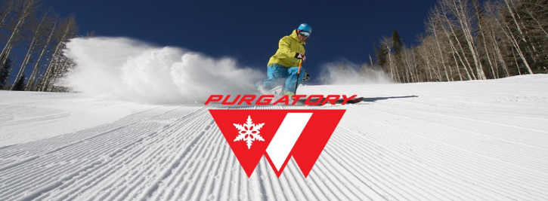

Package included:
- Roundtrip flight from Cleveland, OH to Durango, CO
- Roundtrip transportation
- Welcome party/midweek party
- 6 nights’ accommodations at the Purgatory village condo
- Ski in/ Ski Out
- 4 people per 2 bedroom / 2 bath condo
- Complimentary wi-fi with fully equipped kitchen, fireplace
- Hot tub, heated pools, fitness room
- 5 days riding/skiing at Purgatory.
Mountain Stats: https://www.purgatory.ski/mountain/purgatory-mountain/trail-maps/
- Skiable Area: 1,635 acres
- Vertical Drop: 2,072 feet
- Base Elevation: 8,793 feet
- Summit Elevation: 10,822 feet
- Annual Snowfall: 260 inches
- Lifts: 11 lifts (1 High Speed Six Person,2 HS quad..)
- Trails: 107 trails
- Terrain: 20% Beginner, 45% Intermediate, 35% Advanced/Expert
Link to register online at SportsAmerica: https://www.sportsamerica.com/online/lewispurgatory
Trip Leader: Tom Vannuyen 440-376-1503 Question? Purgatory2026@lewisskiclub.org
* Membership in the Lewis Ski Club is required and is available at: https://lewisskiclub.org

* Does not include baggage fees, any additional fuel surcharges, or airport fees, which may be imposed by the airline prior to departure. Lewis Ski Club reserves the option to change airlines, lodging and/or itineraries.

