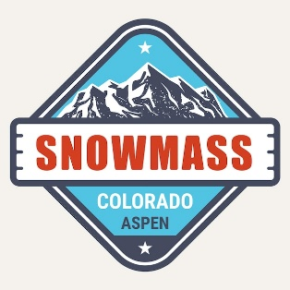
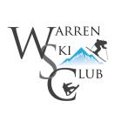
Snowmass Ski Resort near Snowmass Village, CO is situated at 8,100 feet in elevation high up in the Roaring Fork Valley. It is a small mountain village with a large mountain lifestyle located only 9 miles from the world-famous ski town of Aspen, Colorado.
The Crestwood
SLOPESIDE CONDO
Includes: Air & Lodging at the 4.4-star Crestwood Condos and Transportation

2 Bedroom-2 Bath Condos for 4 (6 available) $2205

3 Bedroom-3 Bath Condos for 6 (2 available)
$2385

Single options available.

Crestwood Resort ski-in ski-out access to the 3,339 acres and 4,406 vertical feet of terrain.

Only 42 spots--$600 saves your space.

IKON PASS OR TICKET OPTIONS
Snowmass | Tickets
5-day | $548
3- or 4- day | $416
5-day Sr | $436
4-day Sr | $353
3-day Sr | $270
To access all 4 local areas, the full IKON pass is needed. | The IKON base pass is accepted at Snowmass.
Enter TRIPREBATE50 IN THE DISCOUNT at checkout to apply your instant trip rebate when buying the IKON pass.
Trip Leader: Denise Malovich
ddm183@hotmail.com
724/813-6209
Register online: https://tri.ps/hbiDJ
SnowmaSS, COLORADO
jANUARY 23-30, 2027

The Crestwood Condos 800/356-5949
- True Ski-In/Ski-Out Access
- Complimentary High-Speed Wi-Fi
- Outdoor Heated Pool & Three Hot Tubs
- Fitness Center with Steam Room
- Free Shuttle to the town of Aspen
- Complimentary Laundry Facilities
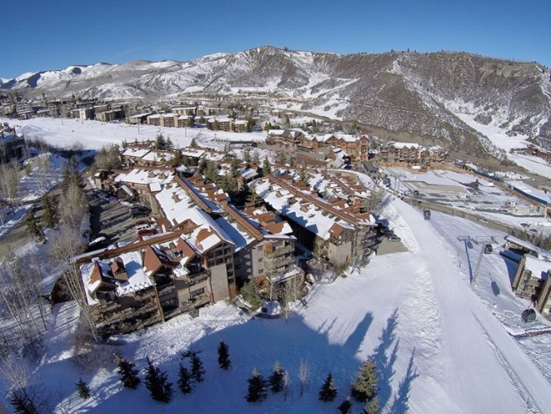
- We’ll be flying United Air Cleveland-Aspen

CANCELLATION POLICY: Written cancellation required. The following penalty will apply: If you cancel before October 6, you will be charged a $100 penalty. The tour operator will charge a $25 to substitute a member. Name changes once air is ticketed (Oct. 16) incur a $150 change fee. Airline baggage policies apply.
TRIP INSURANCE IS HIGHLY RECOMMENDED.

