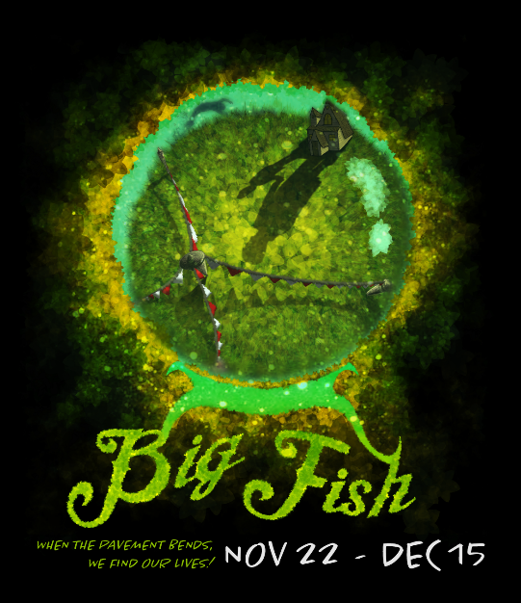
FAGOWEEES THEATER NIGHT
When: Sunday December 15, 2019
Time: 3:00 pm (matinee)
Place: Near West Theater
Cost: $10 members/ $11 nonmembers
Contact: Dana Garcia 440-258-4962
skibunnydrg@yahoo.com
Optional brunch beforehand at the Lux.
Based on the celebrated novel by Daniel Wallace and the acclaimed film directed by Tim Burton, Big Fish tells the story of Edward Bloom, a traveling salesman who lives life to its fullest… and then some! Edward’s incredible, larger-than-life stories thrill everyone around him—most of all, his devoted wife Sandra. But their son Will, about to have a child of his own, is determined to find the truth behind his father’s epic tales.

